Project Initialization and Planning Phase

Date | 21 September 2026
Team ID | MCA(Master of Computer Applications)
Project Name | Air Quality Intelligence: India Air Pollution Monitoring, Operational and Risk Analysis
Maximum Marks | 3 Marks

Define Problem Statements (Customer Problem Statement Template):

Create a problem statement to understand your customer's point of view. The Customer Problem Statement template helps you focus on what matters to create experiences people will love. A well-articulated customer problem statement allows you and your team to find the ideal solution for your customers' challenges. Throughout the process, you’ll also be able to empathize with your customers, which helps you better understand how they perceive your product or service.
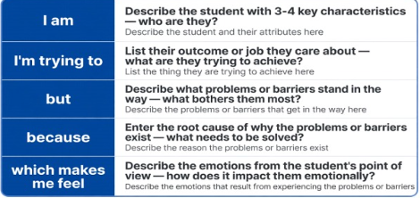
Reference: https://miro.com/templates/customer-problem-statement/
Example:


Problem  Statement (PS) | I am  (Customer) | I’m trying to | But | Because | Which makes me feel
PS-1 | a Data Analyst at a state pollution-control unit | identify the highest-AQI cities and stations | station data is scattered with no easy way to compare or drill in | monitoring teams need to know where to act first | overwhelmed by data volume with no clear priorities
PS-2 | an Urban Policy & Compliance Officer | track AQI_Bucket compliance and issue timely advisories | data isn't organized by threshold, season, or state | I need to time restrictions before pollution peaks | reactive instead of proactive on public health
PS-3 | a Public Health Researcher | link pollutant exposure to population health risk | pollutant and weather data aren't correlated anywhere | I need solid evidence behind health advisories | uncertain my guidance is fully data-backed

